**PRACTICAL- 6**

***ChemSpider Compound Database***

|  |  |  |  |  |  |
| --- | --- | --- | --- | --- | --- |
| ***Compound*** | ***Molecular Formula*** | ***Average Mass (g/mol)*** | ***Monoisotopic Mass (g/mol)*** | ***Structure*** | ***ChemSpider ID*** |
| **Methanol** | CH4O | 32.042 | 32.026215 |  | 864 |
| **Formaldehyde** | CH2O | 30.026 | 30.010565 |  | 692 |
| **Toluene** | C7H8 | 92.141 | 92.062600 |  | 1108 |
| **Phenol** | C6H6O | 94.113 | 94.041865 |  | 971 |
| **Aniline** | C6H7N | 93.129 | 93.057849 |  | 5889 |
| **Pyridine** | C5H5N | 79.102 | 79.042199 |  | 1020 |
| **Acetaldehyde** | C2H4O | 44.053 | 44.026215 |  | 171 |
| **Propylene Glycol** | C3H8O2 | 76.095 | 76.052429 |  | 1030 |
| **Lactic Acid** | C3H6O3 | 90.078 | 90.031694 |  | 96860 |
| **Citric Acid** | C6H8O7 | 192.123 | 192.027003 |  | 305 |

**PRACTICAL- 7**

*Research Papers Database*

|  |  |  |  |  |  |  |
| --- | --- | --- | --- | --- | --- | --- |
| **S.No** | **Title of Paper** | **Authors** | **Year** | **Journal** | **Page No / Article ID** | **DOI / Link** |
| 1 | Biologically Derived Gold Nanoparticles and Their Applications | Roy, A.; Pandit, C.; Gacem, A.; Alqahtani, M. S.; Bilal, M.; Islam, S.; Hossain, M. J.; Jameel, M. | 2022 | Bioinorganic Chemistry and Applications | 8184217 | https://doi.org/10.1155/2022/8184217 |
| 2 | Synthesis and Characterization of Citrate-Capped Gold Nanoparticles and Their Application in Selective Detection of Creatinine (A Kidney Biomarker) | Tirkey, A.; Babu, P. J. | 2024 | Sensors International | 5, 100252 | https://doi.org/10.1016/j.sintl.2023.100252 |
| 3 | Gold Nanoparticles: Biosynthesis and Potential of Biomedical Application | Mikhailova, E. O. | 2021 | Journal of Functional Biomaterials | 12 (4), 70 | https://doi.org/10.3390/jfb12040070 |
| 4 | Biogenic Green Synthesis of Gold Nanoparticles and Their Applications – A Review of Promising Properties | Firdhouse, M. J.; Lalitha, P. | 2022 | Inorganic Chemistry Communications | 143, 109800 | https://doi.org/10.1016/j.inoche.2022.109800 |
| 5 | Utilization of Marine Organisms for the Green Synthesis of Silver and Gold Nanoparticles and Their Applications: A Review | Rizki, I. N.; Klaypradit, W.; Patmawati | 2023 | Sustainable Chemistry and Pharmacy | 31, 100888 | https://doi.org/10.1016/j.scp.2022.100888 |
| 6 | Gold Nanoparticles: Synthesis, Physiochemical Properties and Therapeutic Applications in Cancer | Liu, X.-Y.; Wang, J.-Q.; Ashby, C. R., Jr.; Zeng, L.; Fan, Y.-F.; Chen, Z.-S. | 2021 | Drug Discovery Today | 26 (5), 1284–1292 | https://doi.org/10.1016/j.drudis.2021.01.030 |
| 7 | Biogenic Synthesis of Gold and Silver Nanoparticles Used in Environmental Applications: A Review | Heinemann, M. G.; Rosa, C. H.; Rosa, G. R.; Dias, D. | 2021 | Trends in Environmental Analytical Chemistry | 30, e00129 | https://doi.org/10.1016/j.teac.2021.e00129 |
| 8 | Green Synthesis of Gold and Silver Nanoparticles: Updates on Research, Patents, and Future Prospects | Nadaf, S. J.; Jadhav, N. R.; Naikwadi, H. S.; Savekar, P. L.; Sapkal, I. D.; Kambli, M. M.; Desai, I. A. | 2022 | OpenNano | 8, 100076 | https://doi.org/10.1016/j.onano.2022.100076 |
| 9 | Fungal Endophytes: Treasure Trove for Green Synthesis of Metallic Nanoparticles and Their Biological Applications | Mostafazade, R.; Arabi, L.; Tazik, Z.; Akaberi, M.; Fazly Bazzaz, B. S. | 2024 | Biocatalysis and Agricultural Biotechnology | 60, 103307 | https://doi.org/10.1016/j.bcab.2024.103307 |

**PRACTICAL- 8**

Plagiarism And Detection Software

# Aim:

Plagiarism and its detection softwares

# Introduction:

Plagiarism is the act of using someone else’s work, ideas, or words without proper acknowledgment. It is considered unethical and is a serious offense in academic and professional settings. Plagiarism can be intentional or unintentional, but both are treated equally in most institutions.  
  
To maintain academic integrity, it is important to check our work for originality. Various plagiarism detection tools are available that help in identifying copied or unoriginal content in written work.

# Plagiarism Detection Software:

## 1. Turnitin:

- Turnitin is a widely used plagiarism detection tool in educational institutions.  
- It compares submitted documents against a vast database of academic articles, books, websites, and previously submitted student papers.  
- Turnitin generates a similarity report that highlights the matched text and provides a similarity percentage.  
- It is mostly used by teachers and universities for evaluating assignments and research papers.

## 2. Grammarly:

- Grammarly is an AI-based writing assistant tool.  
- While its primary focus is on grammar, spelling, and writing style, it also includes a plagiarism checker in its premium version.  
- Grammarly checks content against billions of web pages to identify copied text.  
- It is especially useful for students, bloggers, and professionals to refine their writing and ensure originality.

# Conclusion:

Understanding plagiarism and how to avoid it is essential for maintaining academic honesty. Tools like Turnitin and Grammarly help in detecting unoriginal content and improving the quality of writing. By using these tools responsibly, students and professionals can ensure their work is ethical, original, and credible.

**PRACTICAL- 9**

Storage Guidelines for Hazardous Chemicals

# Aim:

To understand and implement proper storage guidelines for hazardous chemicals to ensure safety in laboratories and workplaces.

# Introduction:

Hazardous chemicals can pose serious health, safety, and environmental risks if not stored properly. These substances may be toxic, flammable, corrosive, reactive, or carcinogenic. Proper storage helps in minimizing the risk of accidents, contamination, and chemical reactions.

# Storage Guidelines:

- **Labeling:** All chemical containers must be clearly labeled with the chemical name, concentration, hazard symbols, and date received or opened.  
- **Segregation:** Store chemicals by compatibility groups (e.g., acids away from bases, oxidizers away from organics).  
- **Ventilation:** Store volatile chemicals in well-ventilated areas or fume hoods to avoid accumulation of harmful vapors.  
- **Temperature Control:** Keep chemicals at recommended temperatures. Flammable substances should be stored in flammable-proof cabinets.  
- **Secondary Containment:** Use trays or bins to contain leaks or spills, especially for corrosive or toxic substances.  
- **Accessibility**: Keep frequently used chemicals easily accessible and store heavy containers on lower shelves.  
- **Inventory Management:** Maintain an up-to-date chemical inventory to avoid stockpiling and expired chemicals.  
- **Personal Protective Equipment (PPE):** Always use appropriate PPE when handling hazardous chemicals.

# Conclusion:

Adhering to proper storage guidelines for hazardous chemicals is crucial for ensuring a safe working environment. Awareness, training, and regular inspections can help prevent accidents and promote safety in laboratories and industries.

**PRACTICAL- 10**

Zotero and Mendeley: Reference Management Tools

# Aim:

To understand the use of reference management tools like Zotero and Mendeley for organizing and citing academic sources.

# Introduction:

In academic writing and research, proper citation of sources is essential to maintain credibility and avoid plagiarism. Reference management tools help researchers collect, organize, and cite research papers and other sources efficiently. Zotero and Mendeley are two widely used reference managers that simplify the process of managing bibliographies and in-text citations.

## 1. Zotero:

- Zotero is a free, open-source reference management software developed by the Corporation for Digital Scholarship.  
- It allows users to collect sources from the web and organize them into collections.  
- Zotero can automatically capture citation details from websites, PDFs, and library databases.  
- It integrates with Microsoft Word and Google Docs to insert citations and generate bibliographies in various citation styles.  
- Zotero also provides cloud syncing and group libraries for collaboration.

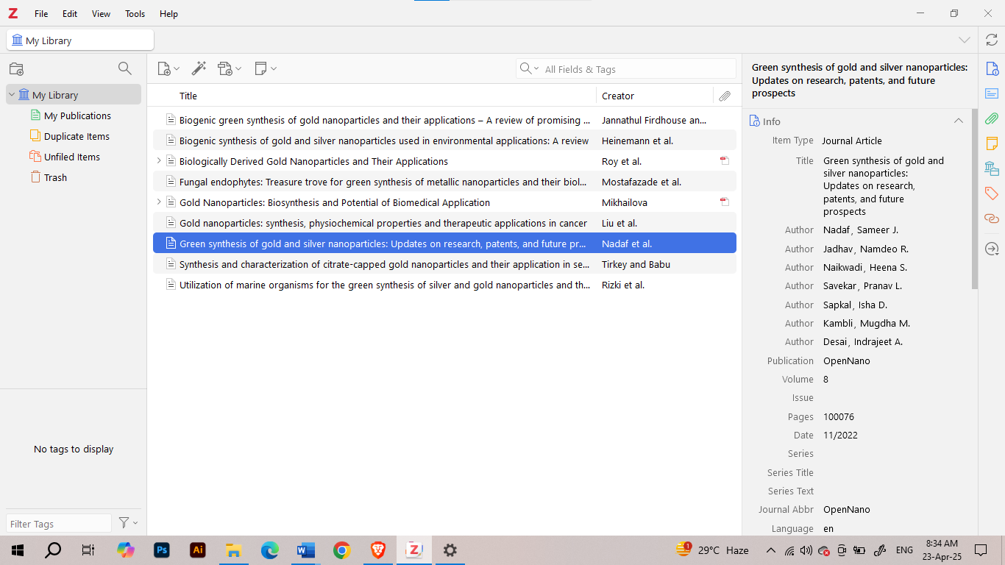

## 2. Mendeley:

- Mendeley is a reference manager and academic social network owned by Elsevier.  
- It allows users to store and annotate PDFs, manage research papers, and generate citations and bibliographies.  
- Mendeley Desktop and Mendeley Reference Manager provide easy access to stored references.  
- It integrates with Microsoft Word and LibreOffice for in-text citation and bibliography creation.  
- Mendeley also provides a platform for researchers to connect and share publications.

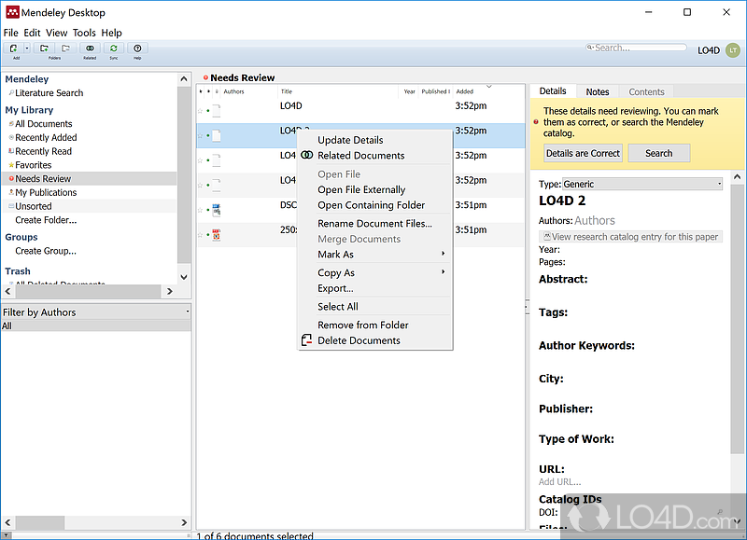

# Conclusion:

Zotero and Mendeley are valuable tools for students and researchers, making reference management easier and more efficient. Using these tools ensures proper citation, helps in organizing research material, and enhances the overall quality of academic work.

**PRACTICAL- 11**

Curve fitting using OriginLab

# Aim:

To understand the concept of curve fitting and learn how to apply it using OriginLab software for analyzing scientific data

# Introduction:

Curve fitting is the process of constructing a curve or mathematical function that best fits a series of data points. It is commonly used in scientific research to analyze experimental data and uncover trends or relationships. OriginLab is a powerful data analysis and graphing software that allows users to perform various types of curve fitting such as linear, polynomial, exponential, and user-defined fits.

**Steps to Perform Curve Fitting in OriginLab:**

* Open OriginLab and import your dataset (e.g., from Excel, CSV, or text file).
* Plot your data using a scatter or line graph.
* Highlight the dataset and go to the Analysis menu > Fitting > choose an appropriate fitting model (Linear, Polynomial, Exponential, etc.).
* Adjust fitting parameters if needed and preview the fitted curve.
* Click OK to generate the fit and view the output with the fitting equation and statistical parameters (like R²).
* You can customize and export the graph with the fitted curve and save the results.

**Applications of Curve Fitting:**

* Analyzing trends in chemical reaction rates.
* Determining constants in physical laws (e.g., Ohm’s law, Boyle’s law).
* Modeling biological responses in dose-response studies.
* Forecasting data in environmental and materials science.

**Conclusion:**

Curve fitting helps interpret and analyze scientific data by revealing patterns and relationships between variables. OriginLab simplifies this process with user-friendly tools, making it an essential software for researchers and students in scientific fields